Communication Media 20
Semester Plan
Warman High School
Roxanne Bitner
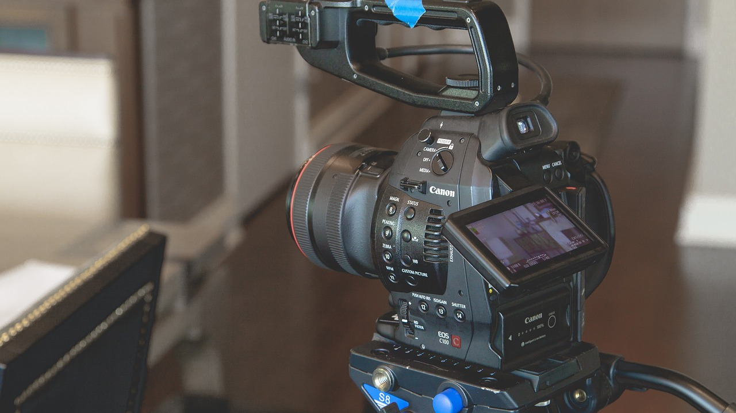
Big Idea: Communications Media 20 (Com Media 20) is an intermediate course intended to give students experience with video planning, capture, and editing techniques. Students will follow the leadership of the senior students as they form a business that will allow them to capture, edit, and add effects to video clips in order to satisfy the requirements of a customer. They will be concerned with providing quality film, audio, and desidesigngn. The final project will require that students incorporate all learning from classes meet client needs. Students will also have the option to prepare a study of a chosen subject, theme, or scene for their own production.
Course Goals:
- To provide the opportunity for students to learn how to use technology efficiently to create quality videos that give consideration to key composition elements.
- To give students the tools to make positive decisions about technology based on an understanding of digital citizenship and the importance of reflective practices.
- To allow students to explore a variety of opportunities that involve the use of video and editing skills. Students will decide to what level they wish to be involved in the Grade 12 video business.

Course Configuration and Evaluation
Module # | Module Name | Activities / Assessment | Module Outcome | Allotment (Hours) | Evaluation  (Overall %)
1 | Starting a Business | - Introduction  - Research how to write a business model, prepare a proposal, and operate a business  - Establish a president, vice president, and departments to develop the structure to meet the needs of the clients  - Learn a simple version of Robert’s Rules of Order for meetings | 99B | 10 | 10%
2 | Interactive Media | - Students will create a website associated with the instructor’s Pro Weebly account | 8B | 8 | 10%
3 | Marketing a Business | - Explore what is involved in Marketing a new business | 99B | 3 | 5%
4 | Working with a Client | - Understanding the client’s needs  - Planning for meetings  - Follow-up | 99B | 5 | 10%
5 | Legal and Ethical Issues (copyright, privacy, and consent) | - Create a plan for personal safety when taking video / proper care of business equipment (template)  - One page exploration of one of the following: copyright, privacy, and consent (template)  - Write a waiver form to use for final project (template) | 2B | 3 | 10%
6 | Video Production | - Review practice with skills learned in ComMedia 20  - Practice interview lighting and setup  - Introduction to After Effects | 6B | 16 | 10%
7 | Audio Production | - Create a conversational script, tape raw footage, edit, and add introductory and closing original music. | 7B | 10 | 10%
8 | Personal Project Planning | - Planning template for final project to include big idea, purpose, equipment, storyboard, waiver, editing log, time limit (template) | 9B | 10 | 10 %
9 | Personal Final Project | - Execute the plan to complete project (rubric)  - Self/peer assessment | 9B | 20 | 20%
10 | Business Evaluaiation | - Students will design an evauation form and evaluate their business | 99B | 5 | 5%
 | Total |  |  | 90 | 100%
* Number of dedicated hours is an estimate and will be influenced by student need.

Resources:
- Writing a Business Plan – Retrieved from https://canadabusiness.ca/business-planning/writing-your-business-plan/
- Three Stages to Every Project – Pre-Production, Production, and Post-Production. Retrieved from http://www.thevideoeffect.tv/2013/06/26/video-pre-production-and-post-production/
- Storyboard Template (online). Retrieved from http://educationresources.serif.com/creating_video/2_design_video_clip/part2-7.html
- Filmmaking 101: Camera Shot Types (online). Retrieved from https://www.bhphotovideo.com/explora/video/tips-and-solutions/filmmaking-101-camera-shot-types
- Learn 5 Editing Basics in Premiere Pro (online). Retrieved from https://helpx.adobe.com/premiere-pro/how-to/easy-video.html
- Adobe Premiere Pro CC tutorials (online) https://helpx.adobe.com/premiere-pro/how-to/what-is-premiere-pro-cc.html?playlist=/ccx/v1/collection/product/premiere-pro/segment/designer/explevel/beginner/applaunch/orientation/collection.ccx.js
- Students are invited to use other online resources that specifically meet their photography/editing needs as determined by their project choice. The instructor will offer guidance and supervision.
Assessment for Learning: Formative assessment will take the form of class discussions (elements of composition, camera use, editing techniques, ethics, careers), visual representations (original video), audio recordings, constructive quizzes (terminology and practices), individual projects (video study), demonstration of understanding with physical equipment (demonstrating improvement through experimentation), and peer/self-assessment.
Assessment of Learning: Student conferences, checklists, rubrics, student business and self-assessment results will be used to ensure consistent, accurate and meaningful representation of student progress and offer support for student learning. The final project will demonstrate the cumulative effect of knowledge and skills learned in the course. The completed client project that is accepted by the client, will constitute a fulfilled obligation and the process will be evaluated by students.
Classroom Expectations Overview:
- Respectful and polite conversation is the only acceptable standard.
- ABSOLUTELY NO FOOD AND DRINK is allowed in the core of the lab (including eating from food in a backpack). Any visible food or drink (open or not) MUST be kept at the front of the lab on the table.
- All students must work on only one machine that is logged in on their own name.
- The expectation is that all students are working at completing Com Media 20 assignments. If these are completed up-to-date, then the students may work at assignments for other classes.
- Students are encouraged to offer verbal assistance to a nearby peer during working time, but are not allowed to physically do any of the work for them. Students are not to work at assignments during lessons unless instructed to do so.
- Monitors are not to be turned or tilted. If you want to show your work to someone else, you must have them come to your monitor to view it. Do not turn the monitor towards them!
- Hoods and earbuds/earphones cannot be worn during instruction. Otherwise, hoods are acceptable.
- All assignments are due as indicated by the teacher. Late assignments will result in the teacher expecting the student to work in the lab at lunch or after school to catch up (as arranged by student).
- Personal devices cannot be used for any purpose not expressly determined by the instructor (i.e. social media, games).
- Students are expected to adhere to digital citizenship guidelines as good stewards of the school's resources and equipment.

