Excel Spreadsheets
Assignment #5 – Loans/Mortgages
- Open a new Excel document and Save As “Assignment5Roxy” (your name).

- Key in the information below. Be sure to adjust the width of the columns to make them as narrow as possible. This way, the chart can be printed more easily. To make many cells the same with, select the letters of the columns (while holding shift) and adjust the last one. The other cells will automatically adjust to the same width. Keep titles as short as possible to keep column as narrow as possible.

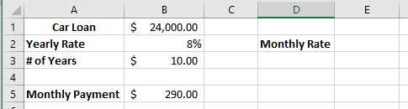

- Click on cell E2 and enter a formula (you determine what it is as per previous learning in this module) to show what the % rate will be each month. Note: the number that should appear is must be shown as %. i.e. .01 is 1%

- Click on cell A7 and enter the information as shown below:
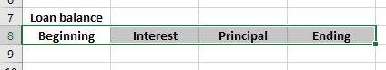

- Click in cell A9 and enter the formula: =B1
Note: This is the starting amount of the loan at $24,000.00

- Decide on the formula to calculate how much will be charged for interest in one month (hint: use the monthly rate you calculated). Place the formula in B9.

- Decide on the formula to calculate how much is left to pay on the loan (hint: this amount is the Beginning amount subtract the interest paid to the bank). Place the formula in C9.

- Now, determine the formula that you will need to use to calculate the amount left owing on the loan after the payment (hint: this would be the original amount subtract the Principal, which is the amount that actually gets applied to your loan). Place the formula in D9.

- Answer the following questions in the cells starting at A11.
- How much is your monthly payment?
- Does your whole payment reduce the amount of the loan?
- Why?
- How much do you think you will pay in interest over the ten year period? Take a guess, and don’t change it later.

Now change the amount of the loan to $30,000. Do you see how all the other figures change?

Now, let’s say you buy a house for $300,000. See the numbers change again?

Facts:

- If you take a $24,000 loan over ten years, you will pay $10,745 interest to the bank over the period of the loan. In other words, you will pay $34,745 for that $24,000 car. The banks are not in the business of losing money.

- If you take a $30,000 loan over ten years, you will pay $13,431 interest to the bank over the period of the loan. In other words, you will pay $43,431 for that $30,000 car. The banks are not in the business of losing money.

- If you take a $300,000 loan over 25 years, you will pay $386,892 interest to the bank over the period of the loan. In other words, you will pay $686,892 for that $300,000 loan. The banks are not in the business of losing money. Do you see why it is important to save?

