Photography 10
Course Outline
Warman High School
Roxanne Bitner
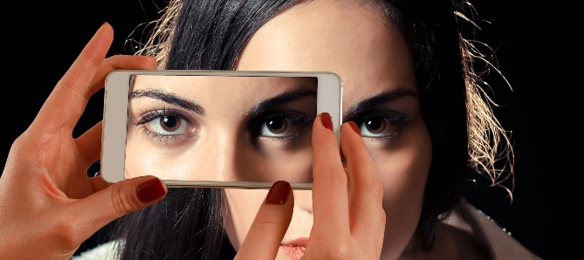
Big Idea: Photography 10 is an introductory course intended to give students a basic understanding of photography and editing. Students will take a variety of photos, learn to edit, and evaluate them according to the elements of composition. The final project will require that students incorporate all learning to prepare a study of a chosen subject, theme, or scene.
Course Goals:
- To provide the opportunity for students to learn how to use technology efficiently to create quality photos that give consideration to key composition elements.
- To give students the tools to make positive decisions about technology based on an understanding of digital citizenship and the importance of reflective practices.
- To allow students to explore a variety of careers that involve the use of photography and editing skills.
Course Configuration and Evaluation
Module # | Module Name | Activities / Assessment | Allotment (Hours) | Evaluation  (Overall %)
1 | Introduction to Photography as a Communication Medium / Exploration of Job Opportunities for Photographers | Illusion Photography Intro  - Website Development (rubric)  - Photography Career exploration PP (rubric) | 6 | 10%  10%
2 | Elements of a Good Photograph | - Photography Elements of Composition PP of original photos (checklist) | 4 | 5%
3 | Camera use: cell phones and school cameras (modes, settings, focus, flash, downloading, accessories) | - Quiz – terminology / technique  Note: since the school only owns one digital SLR, students must use their own devices or small school digitals for photos. | 4 | 5%
4 | Safe and Ethical Practices (Location, Consent, Copyright, Open Source, Creative Commons, Wikimedia, consideration of Norms and Values, Ownership Protection) | Create a plan for personal safety when taking photographs / proper care of equipment (template)  - One page exploration of one of the following: copyright, public domain, open source, creative commons, or stock resources (template)  - Write a waiver form to use for final project (template) | 6 | 10%
5 | Exploring Light & Shadow / Colour Balance | - Photography package demonstrating direction of light, quality of light, diffuse light, natural light, colour, temperature, balance of white, and varying light sources (checklist) | 4 | 5%
6 | History of Photography | - Research & prepare a web page about some historical Photography development | 4 | 5%
7 | Introduction to Photoshop (Adjustment) | - Editing package re: cropping, resizing, file formats, resolution, and brightness / colour / contrast adjustments (checklist) | 15 | 15%
8 | Basic Image Manipulation Editing with Photoshop | - Editing package re: manipulation techniques including compositing, distorting, and perspective (checklist) | 12 | 10%
9 | Project Planning | - Planning template for final project to include big idea, purpose, equipment, waiver, proposed photos, editing log, attractive and logical arrangement (template) | 5 | 5%
10 | Final Project | - Execute plan to complete project (rubric) | 20 | 20%
 | Total |  | 80 | 100%

* Number of dedicated hours is an estimate and will be influenced by student need.

Resources:
- Smartphone Photography 101 (online free resource) Retrieved from https://photographyconcentrate.com/introduction-to-smartphone-photography/#Getting-Started
- Best Photo Lessons. Retrieved from http://bestphotolessons.com/
- How to Use Photoshop as your Photo Editor. Retrieved from https://helpx.adobe.com/photoshop/how-to/photo-editor.html
- Students are invited to use other online resources that specifically meet their photography/editing needs as determined by their project choice. The instructor will offer guidance and supervision.
Assessment for Learning: Formative assessment will take the form of class discussions (elements of composition, camera use, editing techniques, ethics, careers), visual representations (original photos), constructive quizzes (terminology and practices), individual projects (photography study), demonstration of understanding with physical equipment (collections demonstrating improvement through experimentation), and peer/self-assessment (various assignments).
Assessment of Learning: Student conferences, checklists, quizzes, rubrics, and student self-assessment results will be used to ensure consistent, accurate and meaningful representation of student progress and offer support for student learning. The final project will demonstrate the cumulative effect of knowledge and skills learned in the course.

Classroom Expectations Overview:
- Respectful and polite conversation is the only acceptable standard.
- ABSOLUTELY NO FOOD AND DRINK is allowed in the core of the lab (including eating from food in a backpack). Any visible food or drink (open or not) MUST be kept at the front of the lab on the table.
- All students must work on only one machine that is logged in on their own name.
- The expectation is that all students are working at completing Photography 10 assignments. If these are completed up-to-date, then the students may work at assignments for other classes.
- Students are encouraged to offer verbal assistance to a nearby peer during working time, but are not allowed to physically do any of the work for them. Students are not to work at assignments during lessons unless instructed to do so.
- Monitors are not to be turned or tilted. If you want to show your work to someone else, you must have them come to your monitor to view it. Do not turn the monitor towards them!
- Hoods and earbuds/earphones cannot be worn during instruction. Otherwise, head apparel is acceptable.
- All assignments are due as indicated by the teacher. Late assignments will result in the teacher expecting the student to work in the lab after school to catch up (as arranged by student). Due dates are to be honoured. Late assignments will receive a mark of zero immediately and the parent notified the next day. A student can discuss a plan for completion with the instructor. Rewrites of quizzes are not an option.
- Personal devices cannot be used for any purpose not expressly determined by the instructor (i.e. texting, phone calls, social media, games).
- Students are expected to adhere to digital citizenship guidelines as good stewards of the school's resources and equipment.
- It is required that students must have a mask on their person at all times, and must wear the mask if within 6 feet of another person. This is most of the time since space is limited in the lab.

