Photography 30
Course Outline
Warman High School
Roxanne Bitner
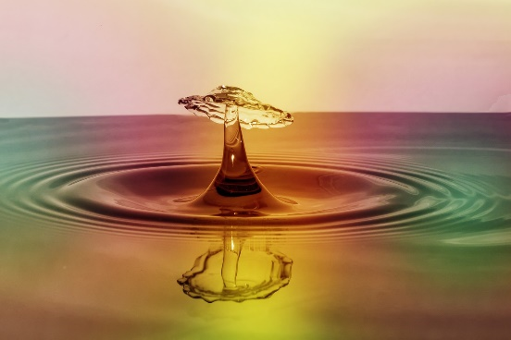
Big Idea: Photography 30 is an upper intermediate course intended to give students a deeper understanding of photography and editing with an emphasis on the artistic aspect of photography. Students will take a variety of photos, then edit and evaluate them according to the elements of composition and artistic merit. A portraiture module will study light and the living subject. The final project will require that students incorporate all learning to prepare a photography portfolio of their choosing (with instructor approval).
Course Goals:
- To provide the opportunity for students to learn how to use technology efficiently to create quality and artistic photos that give consideration to key composition elements.
- To give students the tools to make positive decisions about technology based on an understanding of digital citizenship and the importance of reflective practices.
- To allow students to explore a variety of careers that involve the use of photography and editing skills.
Course Configuration and Evaluation
Module # | Module Name | Assignments/Assessment | Allotment (Hours) | Evaluation  (Overall %)
1 | Introduction to Photography as a Communication Medium / Exploration of Entrepreneurship | - Website Development  - Entrepreneurship Research Project (rubric) | 6 | 10%
2 | Basic Photographic Skills | - Explore the “photographic triangle (shutter speed, aperture, and ISO) when capturing an image.  - Take a variety of photos showing awareness of focus, light, framing, and photographic triangle through quality images. | 6 | 10%
3 | Legal and Ethical Issues (intellectual property, Copyright, patents, industrial Design, Open Source, Ownership Protection) | - Two page exploration of the following: Utilize the Canadian Intellectual Property Office to distinguish between copyright, a patent, and an industrial design (various options)  Write a waiver form to use for final project (template) | 3 | 10%
4 | Portraiture | - Photography package demonstrating the effect of light on living subjects (rubric) with journal | 12 | 10%
5 | Work Experience | - Set up a photo shoot for your family – individual and group shots (You must be in the group shot). | 8 | 10%
6 | Image Adjustments | - Editing package re: selection tools, brushes, vignetting, dodging and burning, and temperature adjustments (checklist) | 10 | 10%
7 | Image Manipulations | - Editing package re: manipulation techniques including altering appearance, composites, apparent age, masking and restoration of old or damaged images (checklist)  - Discussion and journaling re: ethics of manipulation | 11 | 10%
8 | Project Planning | - Planning final project of the student’s choice to include the big idea, purpose, equipment, waiver, proposed photos, editing log, (template) | 2 | 5%
9 | Final Project | - Execute plan to complete project (rubric) | 16 | 20%
10 | Presentations/ Sharing of Images | - Gala class event – attractively displayed Power Point | 4 | 5%
 | Total |  | 78 | 100%
* Number of dedicated hours is an estimate and will be influenced by student need.

Resources:
- Smartphone Photography 101 (online free resource) Retrieved from https://photographyconcentrate.com/introduction-to-smartphone-photography/#Getting-Started
- Best Photo Lessons. Retrieved from http://bestphotolessons.com/
- How to Use Photoshop as your Photo Editor. Retrieved from https://helpx.adobe.com/photoshop/how-to/photo-editor.html
- Students are invited to use other online resources that specifically meet their photography/editing needs as determined by their project choice. The instructor will offer guidance and supervision.
Assessment for Learning: Students will keep reflective journal so that they can have a conference with the instructor and explain what and how they have learned. Formative assessment will take the form of class discussions (elements of composition, camera use, editing techniques, ethics, careers), visual representations (original photos), constructive quizzes (terminology and practices), individual projects (photography study), demonstration of understanding with physical equipment (collections demonstrating improvement through experimentation), and peer/self-assessment (various assignments).
Assessment of Learning: Student conferences, checklists, quizzes, rubrics, and student self-assessment results will be used to ensure consistent, accurate and meaningful representation of student progress and offer support for student learning. The final project will demonstrate the cumulative effect of knowledge and skills learned in the course.
Classroom Expectations Overview:
- Respectful and polite conversation is the only acceptable standard.
- ABSOLUTELY NO FOOD AND DRINK is allowed in the core of the lab (including eating from food in a backpack). Any visible food or drink (open or not) MUST be kept at the front of the lab on the table.
- All students must work on only one machine that is logged in on their own name.
- The expectation is that all students are working at completing Photography 30 assignments. If these are completed up-to-date, then the students may work at assignments for other classes.
- Students are encouraged to offer verbal assistance to a nearby peer during working time, but are not allowed to physically do any of the work for them. Students are not to work at assignments during lessons unless instructed to do so.
- Monitors are not to be turned or tilted. If you want to show your work to someone else, you must have them come to your monitor to view it. Do not turn the monitor towards them!
- Hoods and earbuds/earphones cannot be worn during instruction. Otherwise, head apparel is acceptable.
- All assignments are due as indicated by the teacher. Late assignments will result in the teacher expecting the student to work in the lab after school to catch up (as arranged by student). Due dates are to be honoured. Late assignments will receive a mark of zero immediately and the parent notified the next day. A student can discuss a plan for completion with the instructor. Rewrites of quizzes are not an option.
- Personal devices cannot be used for any purpose not expressly determined by the instructor (i.e. texting, phone calls, social media, games).
- Students are expected to adhere to digital citizenship guidelines as good stewards of the school's resources and equipment.
- It is required that students must have a mask on their person at all times, and must wear the mask if within 6 feet of another person. This is most of the time since space is limited in the lab.

