 | Safety in the Robotics Lab  By Roxy Bitner  There are many safety precautions that must be observed in a robotics lab:  - To maintain orderliness/organization  - To ensure the safety for use of equipment and devices  - To protect lab participants and prevent injury  - To consider the needs/safety of others |  | October 28, 2020
Order and Organization
- Everything has a place for a reason. People should not be tripping over cords, equipment, or materials.
- Backpacks are stored under the computer desks rather than on desktops or in the aisles.
- All your project materials should be stored in the appropriate container and placed in the proper spot at the end of class.
- If you use a glue gun, soldering iron, or heat gun, remember to unplug it, clean the tip, allow time for it to cool, and put it away where it belongs. Tidy the workspace.
- Use only what you need. Do not waste materials. There needs to be enough for everyone.
- Do not glue or solder pieces together without the permission of the instructor.
- Touch only what has been provided to you. For safety and health reasons, do not touch another person’s materials or equipment.
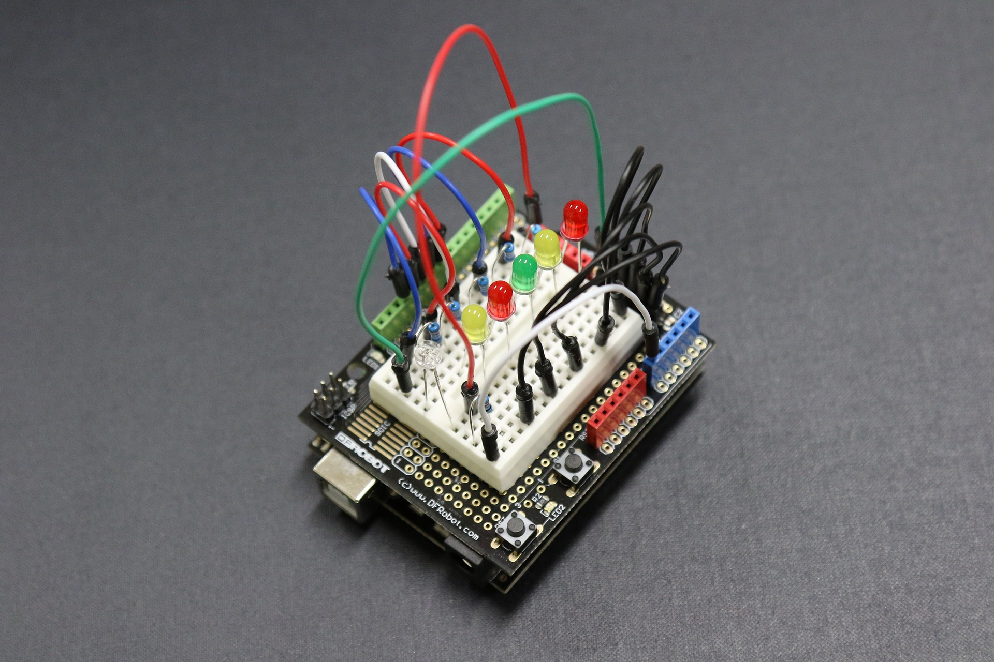
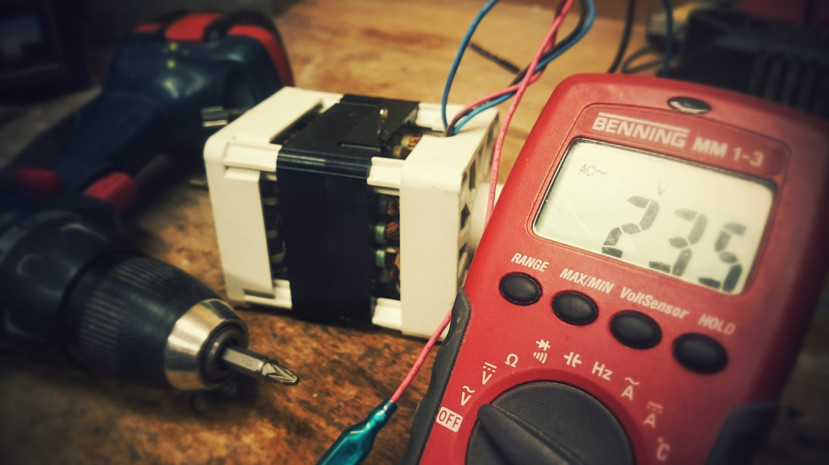
- Tidy every area that you use. Put wire snippings in the garbage, clean solder off of mats, tidy up materials in the station, and leave everything neat for others.
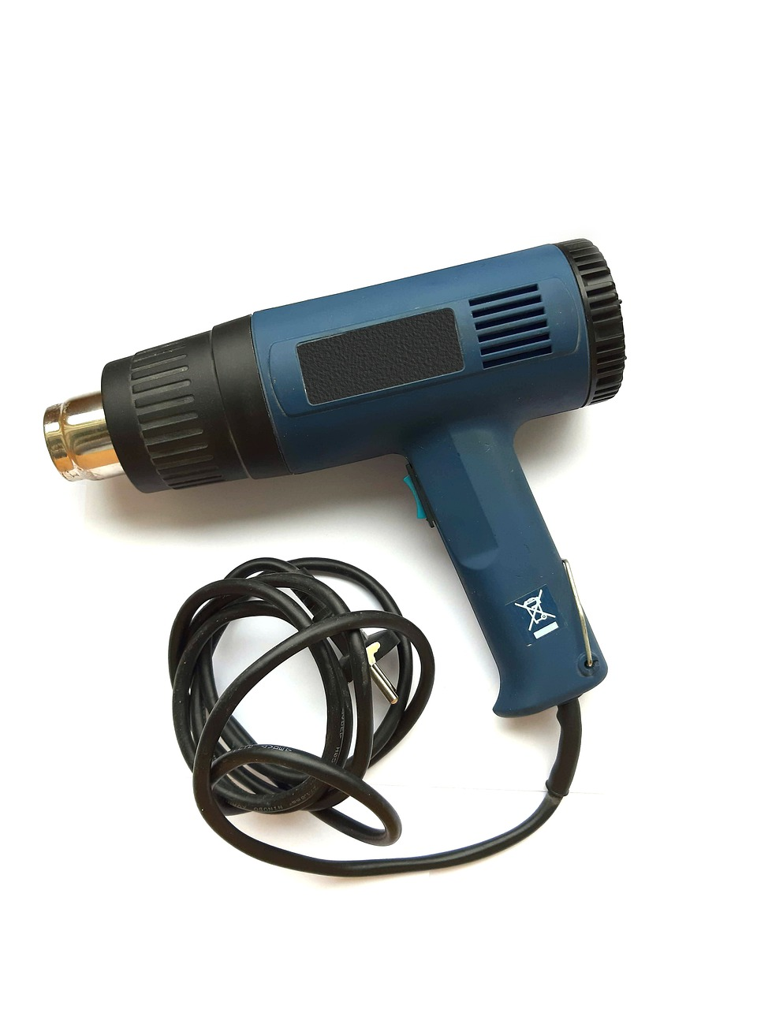
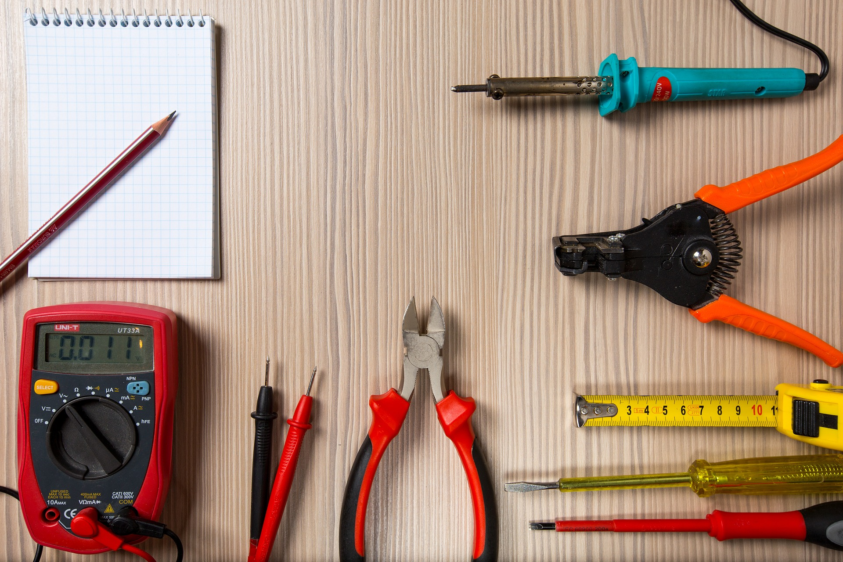
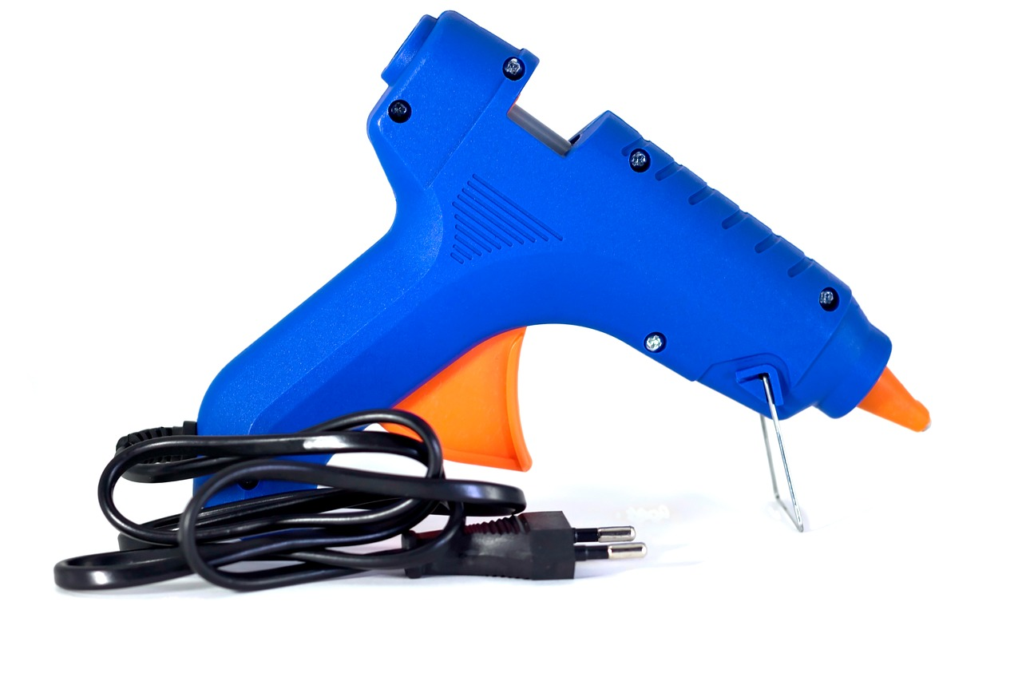
Equipment Safety
- Unplug cords from outlets by pulling the plug, not the cord.
- Use equipment only for the purpose intended.
- Always unplug electrical devices when done using them. Be sure to pull cords up and wrap them carefully.
- If you notice that a cord is frayed, inform the instructor.
- Inform the instructor if a piece of equipment is not working properly or it starts to smell smoky or odd.
- Unplug electrical devices prior to sanitizing. Follow the instructor’s directions regarding sanitization.
- If an Arduino part starts to smoke, unplug the device from the computer an inform the instructor.
- Keep soldering guns in the stands when in use and clean the tip often.
- Do not create short circuits.
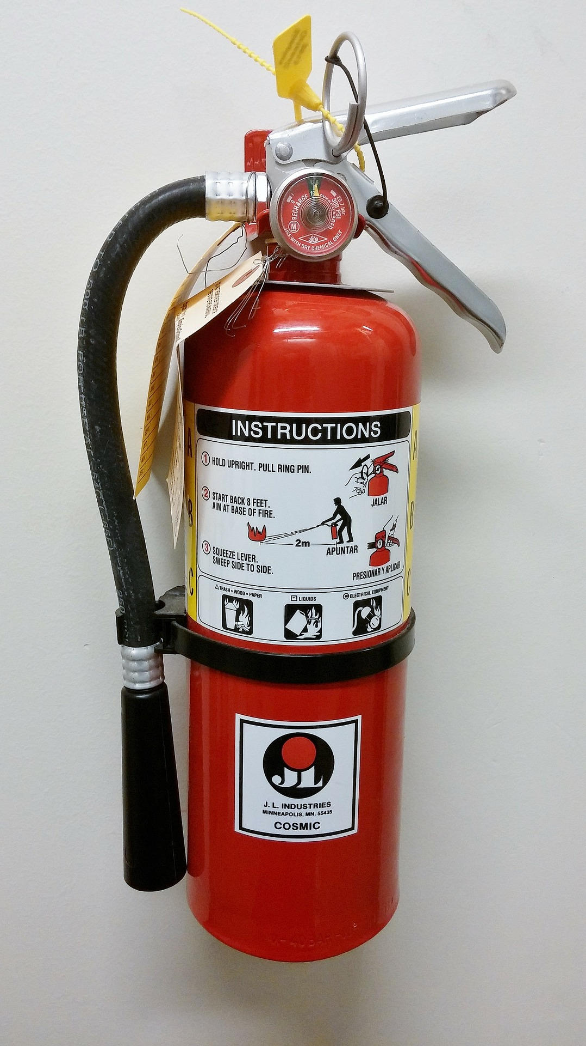
Emergency Stations
- The fire extinguisher is located near the instructor’s desk by the 3D printer.
- A pail of sand is located under the counter beneath the 3D printer to holder anything on fire (i.e. lipo batteries).
- The eyewash station is available in the IA lab down the hall.
- Wipes for sanitizing an area are located on the instructor’s desk.
- Ask the instructor if you need gloves.
- You have been provided with a pair of safety glasses. Use them.
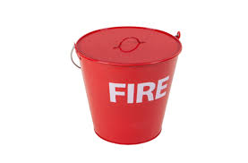
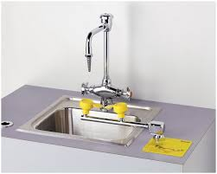
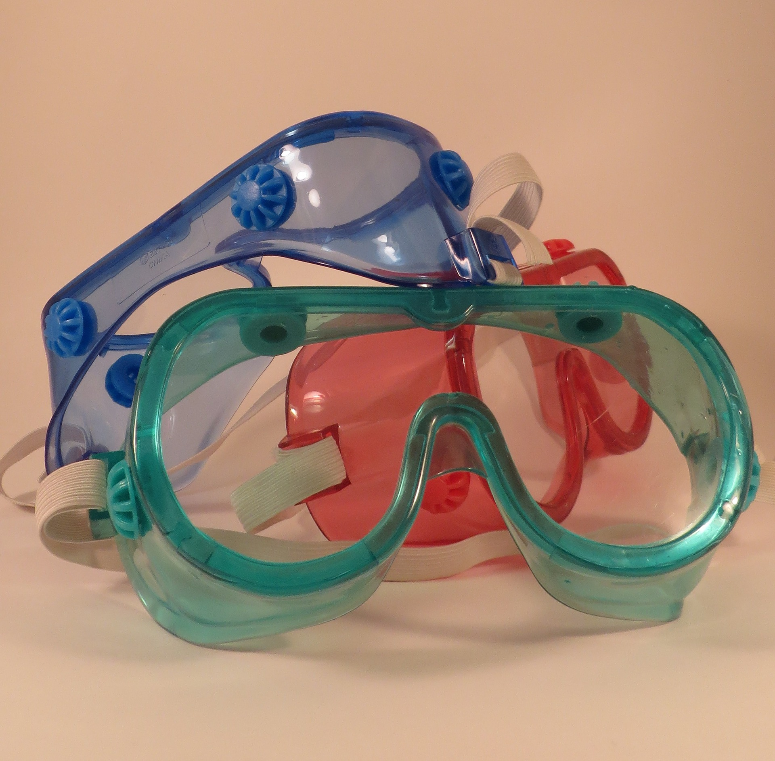
Personal Safety (Since this is an exemplar only, it is not to be copied. It is also not complete since I am not required to do my own assignment.)
- Don’t take chances. Maintain your safety at all times.
- If you injure yourself, get help immediately. The instructor must be informed of all injuries or health concerns.

Consider others
In the Robotics Lab, you are not only responsible your own safety. You must care for the safety of others as well.
Working in close proximity means that we always have to be on the lookout for others.
- Covid-19 prevention is a top priority now. If you are assisting someone else, you must wear gloves and dispose them when done. Wear your mask properly.
- The decisions you make affect others. Doing your job means others can do theirs.
- Look out for others as you move and work in the space. Consider their needs along with yours.

