Terms and Symbols for Quiz
Robotics 20
Wire  - Connects components  - Passes current easily | Wires Joined  - “blobs” indicate that wires are connected | Wires Not Joined  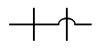  - Sometimes wire not joined  - The bridge leaves no doubt
Cell  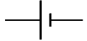  - An energy source  - A single cell | Battery  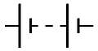  - more than one cell  - longer line is positive  - energy source | 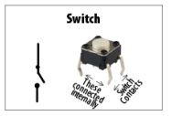
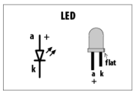 | 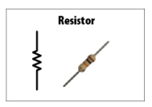  or | Switch  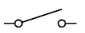  - current flows only when the switch is closed
Lamp  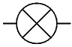  - converts electricity to light | Motor  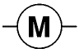  - converts electrical energy to kinetic energy (moves) | Buzzer  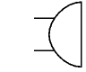  - converts electrical energy to sound
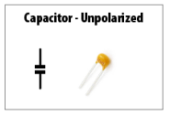 | 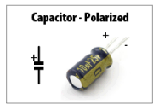 | 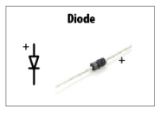
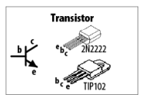 | 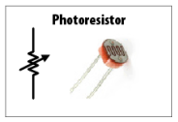 | 